**Letter of Authorization**

**To whom it may concern**

I hereby authorize Infosys Limited ("Infosys") and its representative (NASSCOM Approved Agency) to verify all the information provided in my application of employment and to conduct such enquiries as may be required by Infosys Limited to verify facts of all such information’s provided by me. I hereby declare that this authorization shall be valid till such time I remain an employee of Infosys Limited. I hereby authorize all individuals, private establishments, government establishments/agencies, educational institutions who may have information relevant to this enquiry to co-operate and disclose to Infosys Limited and/or its agents such information as may be required. I hereby release Infosys Limited and all its personnel and agents from any liability which could result, either directly or indirectly, from the disclosure of information by a third party to another party in response to Infosys Limited’s enquiries.

**Signature:** 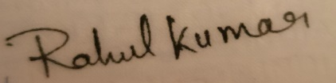

**Name in Block Capitals: RAHUL KUMAR**

**Date: 12-October-2021**

**Emp ID: 1161961**